To implement **Dijkstra’s Algorithm** in C to find the shortest paths from a source node to all other nodes in a graph.

**📘 DIJKSTRA'S ALGORITHM OVERVIEW:**

1. Start with the source node. Set its distance to 0 and others to infinity.
2. Visit the unvisited node with the smallest known distance.
3. Update the distances to its neighbors.
4. Mark the node as visited.
5. Repeat until all nodes are visited.

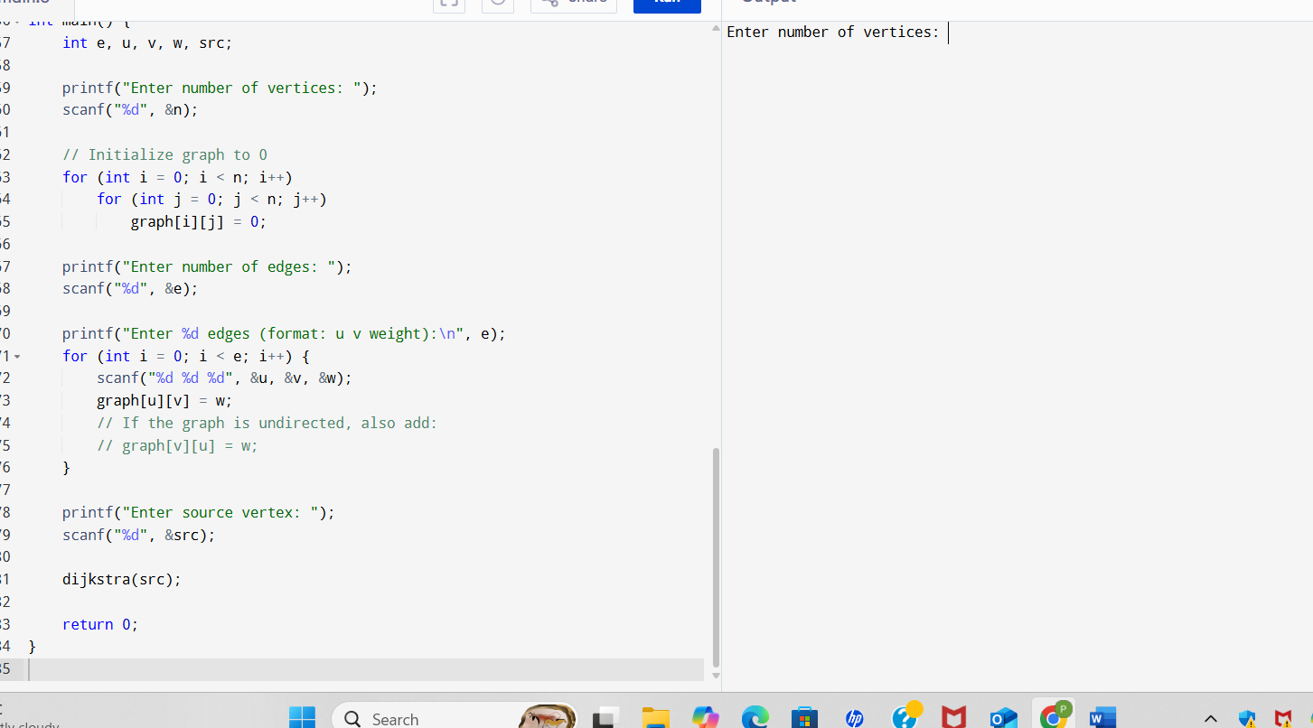

**SAMPLE OUTPUT:**

Enter number of vertices: 5

Enter number of edges: 7

Enter 7 edges (format: u v weight):

0 1 10

0 3 5

1 2 1

1 3 2

2 4 4

3 1 3

3 2 9

Enter source vertex: 0

Vertex Distance from Source (0)

0 0

1 8

2 9

3 5

4 13